1.Explain The Training CNN Architecture
training a supervised deep neural network means searching a set of values of parameters (or weights) of the network at which the loss function has minimum value. Gradient descent is an optimization technique which is used to minimize the error by calculating gradients necessary to update the values of the parameters of the network.

The most common and successful learning algorithm for deep learning models is gradient descent-based backpropagation in which error is propagated backward from last layer to the first layer. In this learning technique, all the weights of a neural network are either initialized randomly or initialized by using probability distribution. An input is fed through the network to get the output.

1)Training supervised deep neural network is formulated in terms of minimizing a loss Function
2) training a supervised deep neural network means searching a set of values of parameters (or weights) of the network at which the loss function has minimum value.
3) Gradient descent is an optimization technique which is used to minimize the error by calculating gradients necessary to update the values
4) The most common and successful learning algorithm for deep learning models is gradient descent-based backpropagation in which error is propagated backward from last layer to the first layer
5) all the weights of a neural network are either initialized randomly or initialized by using probability distribution.

An input is fed through the network to get the output.

The obtained output and the desired output are then used to calculate the error using some cost function (error function).

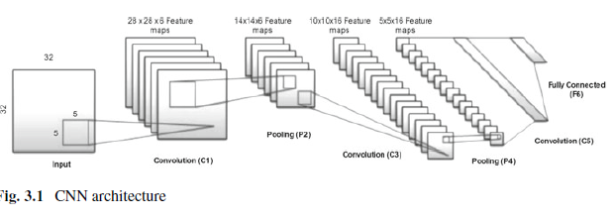

TheCNNmodel is similar to LeNet but uses ReLU (which has become a standard in deep networks) as activation function, max-pooling, instead of average pooling. The CNN model consists of three convolution layers, two subsampling layers, and one fully connected layer producing 10 outputs.

The first convolution layer convolves input of size 32×32 with six 5 × 5 filters producing six 28 × 28 feature maps. Next, pooling layer downsamples these six 28 × 28 feature maps to size 14 × 14. Second convolution layer convolves the down-sampled feature maps with 5 × 5 filters producing 16 feature
maps of size 10 × 10. Second pooling layer down-samples the input producing 16 feature maps of size 5 × 5. The third convolution layer has the input of size 5 × 5 and the filter of size 5 × 5, so no stride happens. We can say that this third layer has 120 filters of size 5 × 5 fully connected to each of the 16 feature maps of size 5 × 5. Last layer in the architecture is a fully connected layer containing 10 units for 10 classes. The output of the fully connected layer is fed to cost function (Softmax) to calculate the error.

2.What Is Loss Layer.
During training, an input is fed to the network and output is obtained. The obtained output is compared against the actual output to calculate the error or loss. The calculated error is then used to update the weights of the network. The process is repeated until the error is minimized.

The function which is used to calculate the error or loss is called cost/loss function, and there are quite a few loss functions available and for and cross-entropy loss function. The Mean Squared Error (MSE) of the CNN model can be given as softmax layer the two commonly used loss functions are Mean Squared Error (MSE) and cross-entropy loss function. The Mean Squared Error (MSE) of the CNN model
can be given as

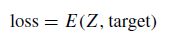

The loss function E is defined as

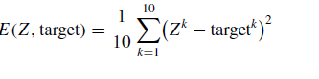

Zk is the kth output (in this case the network will produce 10 outputs representing class probabilities) generated by the CNN and targetk is the ground truth of the input. E(Z, target) is the error/loss which represents how far the prediction of the network is from the actual target.

E(Z, target) is the error/loss which represents how far the prediction of the network is from the actual target. The purpose of training is to minimize the loss function and to do so the weights of the network are continuously updated until the minimum value is achieved. After calculating the error, the gradient of the loss function with respect to each weight of the neural network is calculated. The weights of the network are then updated with their respective gradients. This process is continued until the total error is minimized.

3.What Is Loss Function.
The loss function E is differentiable and can be differentiated w.r.t any weight at any layer using chain rule. In backpropagation, the weights of the last layer are updated first followed by second last layer and so on. To start with, let us find the
derivative of the cost function w.r.t weight wki at last layer F6 using chain rule.

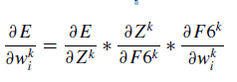

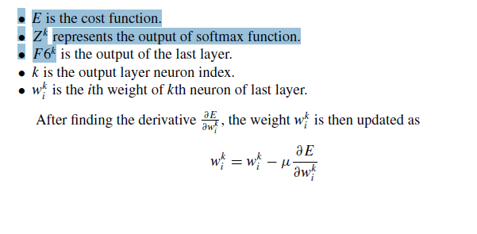
where wk i is the updated weight and μ is the learning rate.

4.What Is Mean Squared Error (L2) Loss, Cross-Entropy Loss, Softmax Classifier

A loss function is used to calculate the error (difference between prediction and ground truth label) during the training process of a deep network.
Depending upon the application, there are many loss functions that can be used in deep learning networks. For example, mean squared error (L2) loss, cross-entropy loss, and hinge loss are commonly used in classification problem. Absolute deviation error (L1) loss is suitable for regression problem.

Mean Squared Error (L2) Loss

The most commonly used loss function in machine learning is Mean Squared Error(MSE) loss function. The MSE function, also known as L2 loss function, calculates the squared average error E of all the individual errors, and is given by

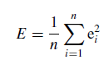

where ei represents the individual error of ith output neuron which is given by

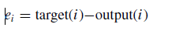

During training process, a loss function is used at the output layer to calculate the error and its derivative (gradient) is propagated in the backward direction of the network. The weights of the network are then updated with their respective gradients.

Cross-Entropy Loss

Cross-entropy loss is another loss function mostly used in regression and classification problems. Cross-entropy loss is given by

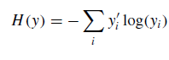

where y_i is the target label, and yi is the output of the classifier. Cross-entropy loss function is used when the output is a probability distribution, and thus it is preferred loss function for softmax classifier.

Softmax Classifier

Softmax classifier is a mathematical function which takes an input vector and produces output vector in range (0–1), where the elements of the output vector add up to 1. That is, the sum of all the outputs of softmax function is 1. Softmax function is given by
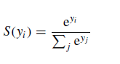
Since softmax function outputs probability distribution, it is useful in the final
layer of deep neural networks for multiclass classification.

5. What Are The Various Variants Of This Optimizing Technique.
Gradient descent is an optimization technique used to minimize/maximize the cost function by calculating gradients necessary to update the values of the parameters of the network.
- Gradient Descent Variants: Batch Gradient Descent (GD):Depending on the amount of data, we trade off between the accuracy of parameter updates (weights and biases) and the time it takes to perform an update(one parameter update per epoch)

- Batch Gradient Descent (GD):
- Stochastic Gradient Descent (SGD): The problem can be rectified by using Stochastic Gradient Descent (SGD),also known as incremental gradient descent, where gradient is computed for one training example at a time followed by updating of parameter values.
- Mini-batch Gradient Descent: Mini-batch gradient descent also known as mini-batch SGD is a combination of both standard gradient descent and SGD techniques.Mini-batch SGD divides the entire training set into mini-batches of n training examples and performs the updating of parameter values for each mini-batch.

- AdaGrad: The learning rate is set independently of gradients which may sometimes cause problems. For example, if the gradient is large, large learning rate would result in large step size, which means it may not achieve the optimum value as it may keep oscillating around the optimum value, and if the magnitude of gradient is small, a small learning rate may result in slow convergence
- AdaDelta: Ada Delta limits the number of previous gradients to some fixed size x and then the average of these past gradients is stored for efficiency. The average value Avg ∇2 t at time t only depends on previous average and current gradient
- RMSProp: The vanishing learning rate in AdaGrad can be rectified by using RMSProp. It is a modified version of AdaGrad which discards history from the distant past by introducing exponentially weighted moving average. RMSProp uses sign of the gradient instead of the magnitude of the gradient to update the weights
- Adam: Adam saves an exponentially decaying average of previous squared gradients vt,Adam also computes the average of the second moments of the gradients mt mt and vt which are values of the mean and uncentered variance
6.Different Between Gradient Descent Variants Vs Batch Gradient Descent (GD) Vs stochastic Gradient Descent (SGD)

Batch Gradient Descent
Batch gradient descent uses the entire dataset to compute the gradient for each parameter update.
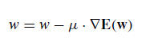
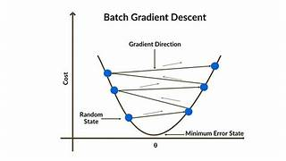
weight parameter w is computed for the entire training set
- where ∇E(w) is the error gradient with respect to weight w
- μ is the learning rate that defines the step size to take along the gradient
- The learning rate is a hyperparameter which cannot be too high or too low.
- Large value of learning rate can miss the optimum value, and too low learning rate will result in slow training time.
Pros
- Stableness: Batch gradient descent is stable in gradient and convergence because it uses the entire dataset to compute the gradient at each step. This can make it more likely to find the global minimum of a function.
- Computation cost: Batch gradient descent is computationally efficient, as it uses the entire training dataset to compute the gradient of the cost function at each iteration, and the parameters are only updated once after each epoch.
Cons
- Training speed: Batch gradient descent can be slow to converge when the training dataset is very large, as it uses the entire dataset to compute the gradient at each iteration. This can make training time-consuming and impractical in some cases.
- Memory requirement: Batch gradient descent requires high memory for large datasets because it processes all the samples in the training dataset at the same time.
- Suboptimal solution: Batch gradient descent tends to converge to a suboptimal solution (local minima or saddle point). This is because the gradients are stable and it’s hard to jump out of a local minimum.

Stochastic Gradient Descent
- Stochastic gradient descent updates the model weights using one record at a time. The problem can be rectified by using Stochastic Gradient Descent (SGD),also known as incremental gradient descent, where gradient is computed for one training example at a time followed by updating of parameter values. where ∇E(w; x(i); y(i)) is the gradient of loss function—E(w) w.r.t parameters w,for the training example {x(i), y(i)}.

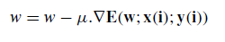
Pros
- Less memory needed: SGD requires less memory as it uses a single training sample to compute the gradient of the cost function at each iteration.
- Escape suboptimal solution: Stochastic gradient descent provides opportunities to discover new and potentially better weights. This helps to escape the local minima or saddle points.
- Online learning: SGD is well-suited for online learning, where the model is trained incrementally on streaming data. This makes it a good choice for applications that require real-time prediction or model updates.
Cons
- Stableness: Stochastic gradient descent is not stable. The frequent updates of the weights can produce noisy gradients, causing the loss to fluctuate instead of slowly decreasing.
- Convergence: Stochastic gradient descent tends to have higher variance and may diverge instead of converging to the global minimum.
- Computation cost: Stochastic gradient descent is computationally expensive because the parameters are updated for each sample.

Mini-batch Gradient Descent
Mini-batch gradient descent lies between batch gradient descent and stochastic gradient descent, and it uses a subset of the training dataset to compute the gradient at each step. Mini-batch gradient descent combines the benefits of batch gradient descent and stochastic gradient descent.
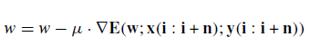
Typical mini-batch size varies from 50 to 256 and should also be chosen sensibly according to the following factors:
• Large batch sizes provide more accurate gradients but have high memory requirements.
• Small batch sizes can offer a regularizing effect but require a small learning rate to maintain stability owing to the high variance in the estimate of the gradient.
This in turn increases the training time because of the reduced learning rate.

Pros
- Computation cost: Mini-batch gradient descent is more computationally efficient than stochastic gradient descent because it updates the parameters after a batch of samples.
- Stableness: Mini-batch gradient descent is more stable than stochastic gradient descent because it utilizes the information from more data.
- Less memory needed: Mini-batch gradient descent requires less memory than batch gradient descent because it uses a small subset of training samples to compute the gradient of the cost function at each iteration.
Cons
- Mini-batch size: Mini-batch gradient descent can be affected by the choice of mini-batch size, as a mini-batch size that is too small can decrease the convergence rate, while a mini-batch size that is too large can make the algorithm behave similarly to batch gradient descent. Batch size is an important hyperparameter to tune in mini-batch gradient descent.

7. Write A Short Note On Mini-Batch Gradient Descent.
- Mini-batch gradient descent also known as mini-batch SGD is a combination of both standard gradient descent and SGD techniques.
- Mini-batch SGD divides the entire training set into mini-batches of n training examples and performs the updating of parameter values for each mini-batch.

Typical mini-batch size varies from 50 to 256 and should also be chosen sensibly
according to the following factors:
• Large batch sizes provide more accurate gradients but have high memory requirements.
• Small batch sizes can offer a regularizing effect but require a small learning rate to maintain stability owing to the high variance in the estimate of the gradient.
This in turn increases the training time because of the reduced learning rate.

8.Explain Adagrad, Adadelta Adv And Disadv.

- The learning rate is set independently of gradients which may sometimes cause problems. For example, if the gradient is large, large learning rate would result in large step size, which means it may not achieve the optimum value as it may keep oscillating around the optimum value, and if the magnitude of gradient is small, a small learning rate may result in slow convergence.

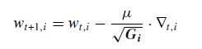

Advantage of AdaGrad:
- AdaGrad is that learning rate is automatically adjusted, and there is no need to manually tune it.
Disadvantage:
- the sum in the denominator keeps on increasing which gradually causes the learning rate to decay. This decaying learning rate can slow down the learning or stop the learning completely.
Adadelta:
- Ada Delta limits the number of previous gradients to some fixed size x and then the average of these past gradients is stored for efficiency. The average value Avg ∇2 t at time t only depends on previous average and current gradient.

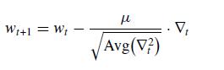

9. Explain Rmspros Optimizer And Adam Optimizer.

Rmspros Optimizer:

- The vanishing learning rate in AdaGrad can be rectified by using RMSProp.
- It is a modified version of AdaGrad which discards history from the distant past by introducing exponentially weighted moving average.
- RMSProp uses sign of the gradient instead of the magnitude of the gradient to update the weights.
The working of RMSProp optimizer is as follows:
- Set same magnitude of updates for all weights. Set maximum and minimum allowable weight updates to max and min, respectively.
- (b) At each iteration, if signs of current gradient and previous gradient are same, then increase learning rate by a factor of 1.2, i.e. η η + 1.2. Therefore, the update t+1 j becomes
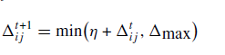

Adam(Adaptive Moment Estimation)
- Adam saves an exponentially decaying average of previous squared gradients vt
- Adam also computes the average of the second moments of the gradients mt
- mt and vt which are values of the mean and uncentered variance
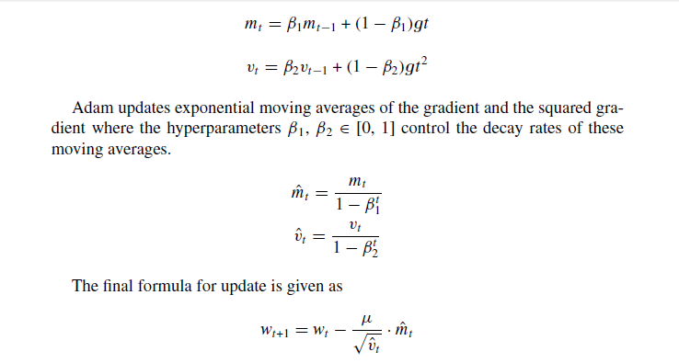

10.Explain The Challenges In Training Deep Networks
1. Vanishing Gradient
Any deep neural network with activation function like sigmoid, tanh, etc. and training through backpropagation suffers from vanishing gradient problem. Vanishing gradient makes it very hard to train and update the parameters of the initial layers in the network. This problem worsens as the number of layers in the network increases.
The aim of backpropagation in neural networks is to update the parameters such that the error of the network is minimized and actual output gets closer to the target output.

2. Training Data Size:
Deep networks use training data for learning and are capable of learning complex
Nonlinear relationships between input data and output label. Deep networks require a large number of parameters to be learnt before it can be utilized to deliver the desired result. The number of parameters in deep models is large. More complex models mean more powerful abstraction, and more parameters which require more data. So, the size of training data is an important factor which can influence the success of deep models
3. Overfitting and Underfitting:
The ability of a machine learning model to perform well on new and unseen data is called generalization. Generalization is one of the objectives of a good deep learning model. To estimate the generalization ability of a deep learning model, it is tested on data collected separately from the training set.
Deep learning models can suffer from two problems, viz. overfitting and underfitting and both can lead to poor model performance.
Overfitting occurs when a model is trained, and it performs so well on training
data that it is unable to generalize to new data.

Underfitting occurs when a model is not able to learn properly and its performance on the training set is poor.
The most common problem in deep learning is overfitting. Deep models like Convolutional Neural Network (ConvNet) have a large number of learnable parameters that must be learnt before they can be utilized to perform the task of interest. In order to train these models, extensively large training data with a specific end goal is required to accomplish the desired performance. If the training data is too small compared to the number of weights to be learned, then the network suffers from overfitting.
Overfitting is a common problem in deep networks, however, there are few techniques available that can be used in deep learning models to limit overfitting:
(a) Increase the training dataset.
(b) Reducing network size.
(c) Data augmentation: Modifying the current training data in a random way (Scaling, zooming, translation, etc.) to generate more training data.
(d) Interpolate weight penalties like L1 and L2 regularization and soft weight sharing.
(e) Dropout: The most popular technique to reduce overfitting is Dropout. Dropout refers to dropping out neurons/units in a neural network during training.

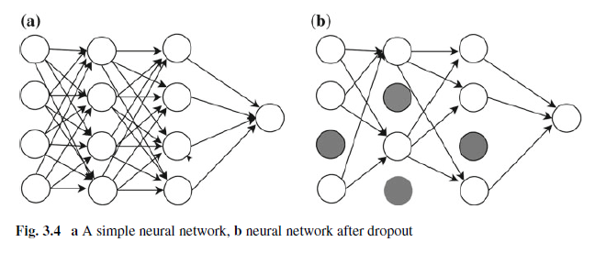
4. High-Performance Hardware:

Training deep models on huge datasets require machines with sufficient processing power and memory. In order to get high efficiency and quick training time, it is highly recommended to use multi-core high-performance Graphics Processing Units (GPUs). These high-performance machines, GPUs, and memory are very costly and consume a lot of energy.

